# **Chapter 1**

# **Data Modeling using Entity Relatioship (E-R) Diagram**

# **Contents**

* Conceptual Data Model for Database Design
* ER Model Concepts
  + Entities and Attributes
  + Entity Types, Value Sets, and Key Attributes
  + Relationships and Relationship Types
  + Weak Entity Types
  + Roles and Attributes in Relationship Types
* ER Diagrams - Notation

**Overview of Database**

* Two main activities:
  + Database design
  + Applications design
* Focus in this chapter on database design
  + To design the conceptual schema for a database application
* Applications design focuses on the programs and interfaces that access the database
  + Generally considered part of software engineering

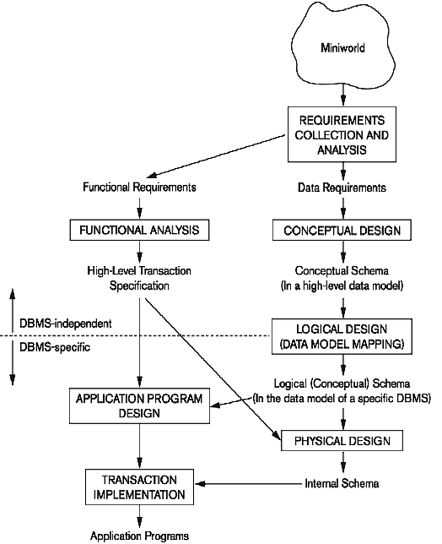

**Entity-Relationship (ER) Model Concepts**

* A popular high-level conceptual data model
* Entities and Attributes
  + Entities are specific objects or things in the mini-world that are represented in the database.
    - For example the EMPLOYEE John Smith, the Research DEPARTMENT, the ProductX PROJECT
  + Attributes are properties used to describe an entity.
    - For example an EMPLOYEE entity may have the attributes Name, SSN, Address, Gender, BirthDate
  + A specific entity will have a value for each of its attributes.
    - For example a specific employee entity may have Name='John Smith', SSN='123456789', Address ='731, Fondren, Houston, TX', Gender='M', BirthDate='09-JAN-55‘
  + Each attribute has a *value set* (or data type) associated with it – e.g. integer, string, subrange, enumerated type, etc

# **Types of Attributes**

* Simple
  + Each entity has a single atomic value for the attribute. For example, SSN or Gender.
* Composite
  + The attribute may be composed of several components. For example:
    - Address(Apt#, House#, Street, City, State,

ZipCode, Country), or

* + - Name(FirstName, MiddleName, LastName).
    - Composition may form a hierarchy where some components are themselves composite.
* Multi-valued
  + An entity may have multiple values for that attribute. For example, Color of a CAR or PreviousDegrees of a STUDENT.
    - Denoted as {Color} or {PreviousDegrees}.

**Example of a Composite Attribute**

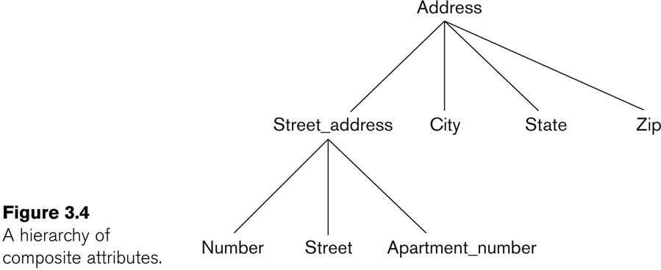

* In general, composite and multi-valued attributes may be nested arbitrarily to any number of levels, although this is rare.
  + For example, PreviousDegrees of a STUDENT is a composite multi-valued attribute denoted by {PreviousDegrees (College, Year, Degree, Field)}
  + Multiple PreviousDegrees values can exist
  + Each has four subcomponent attributes:
    - College, Year, Degree, Field
* Complex Attributes
  + Nested composite and multivalued attributes
    - Ex. A person has more than one residence and each residence can have a single address and multiple phones

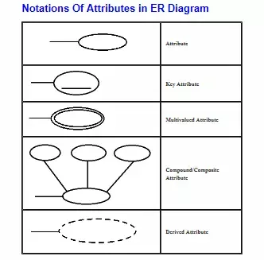

# **Stored and Derived Attributes**

### An derived attribute is derived from a stored attribute

#### Ex. We can derive a man’s age

from his birthday.

**Null Values** -

Its meaning includes

* + An attribute value is not applicable
  + An attribute value is unknown
    - The value exists but is missing
    - The value is unknown whether it exists

**Entity Types and Key Attributes**

* Entities with the same basic attributes are grouped or typed into an entity type.
  + For example, the entity type EMPLOYEE and PROJECT.
* An attribute of an entity type for which each entity must have a unique value is called a key attribute of the entity type.
  + For example, SSN of EMPLOYEE.
* A key attribute may be composite.
  + VehicleTagNumber is a key of the CAR entity type with components (Number, State).
* An entity type may have more than one key.
  + The CAR entity type may have two keys:
    - VehicleIdentificationNumber (popularly called VIN)
    - VehicleTagNumber (Number, State), aka license plate number.
* Each key is underlined

**Displaying an Entity Type**

* In ER diagrams, an entity type is displayed in a rectangular box
* Attributes are displayed in ovals
  + Each attribute is connected to its entity type
  + Components of a composite attribute are connected to the oval representing the composite attribute
  + Derived attributes are denoted by dotted ovals
  + Each key attribute is underlined
  + Multivalued attributes displayed in double ovals
* See CAR example below
* Entity Type CAR with two keys and a corresponding Entity Set

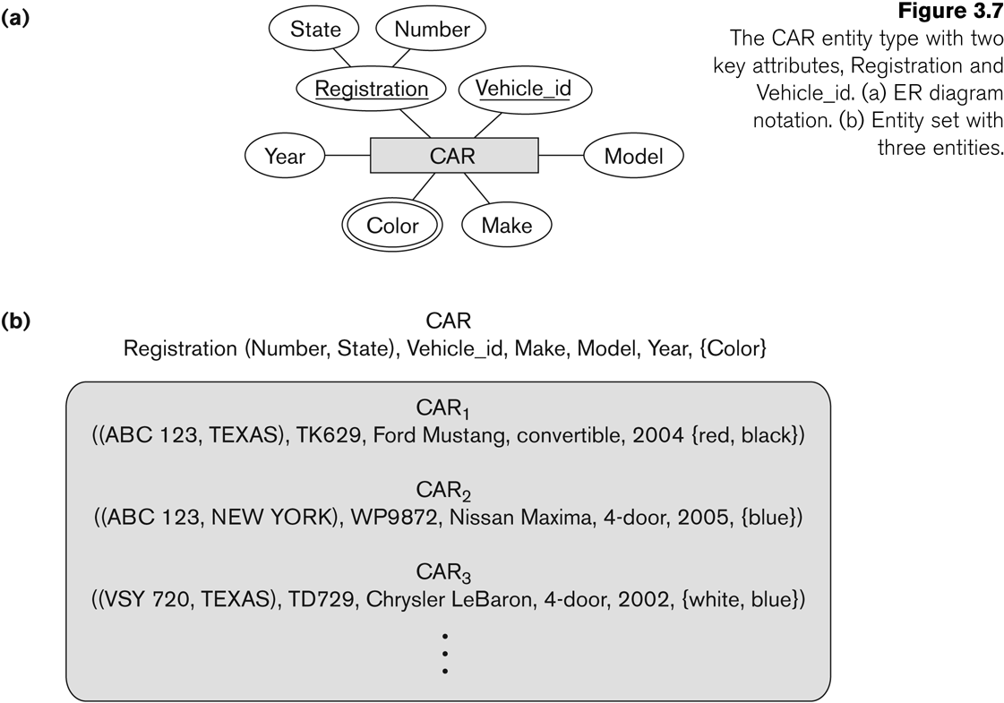

**Entity Set Value Sets (Domains) of Attributes**

* Each entity type will have a collection of entities stored in the database
  + Called the **entity set** (also called the

**extension** of the entity type)

* + An entity type describes the **schema** or

**intension** for a set of entities

* Previous slide shows three CAR entity

instances in the entity set for CAR

* Same name (CAR) used to refer to both the entity type and the entity set
* Entity set is the current *state* of the entities of that type that are stored in the database
* Each simple attribute is associated with a **value set** (or **domain** of values)
  + Ex. The **Age** attribute of **EMPLOYEE** to be the set of integer numbers between 16 to 70

# **Initial Design of Entity Types for the COMPANY Database Schema**

* Based on the requirements, we can identify four initial entity types in the COMPANY database:
  + DEPARTMENT
  + PROJECT
  + EMPLOYEE
  + DEPENDENT
* Their initial design is shown on the following slide
* The initial attributes shown are derived from the requirements description

**Initial Design of Entity Types:**

EMPLOYEE, DEPARTMENT, PROJECT, DEPENDENT

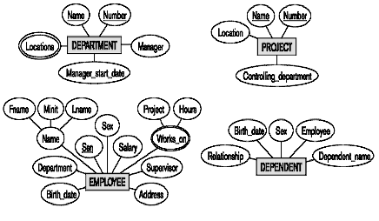

**Refining the Initial Design by Introducing Relationships**

* The initial design is typically not complete
* Some aspects in the requirements will be represented as **relationships**
* ER model has three main concepts:
  + Entities (and their entity types and entity sets)
  + Attributes (simple, composite, multivalued)
  + Relationships (and their relationship types and relationship sets)
* We introduce relationship concepts next

**Relationships and Relationship Types**

* A **relationship** relates two or more distinct entities with a specific meaning.
  + For example, EMPLOYEE John Smith *works on* the ProductX PROJECT, or EMPLOYEE Franklin Wong *manages* the Research DEPARTMENT.
* Relationships of the same type are grouped or typed into a **relationship type**.
  + For example, the WORKS_ON relationship type in which EMPLOYEEs and PROJECTs participate, or the MANAGES relationship type in which EMPLOYEEs and DEPARTMENTs participate.
* The degree of a relationship type is the number of participating entity types.
  + Both MANAGES and WORKS_ON are *binary* relationships.

**Relationship Instances of the WORKS_FOR N:1**

Relationship between EMPLOYEE and DEPARTMENT

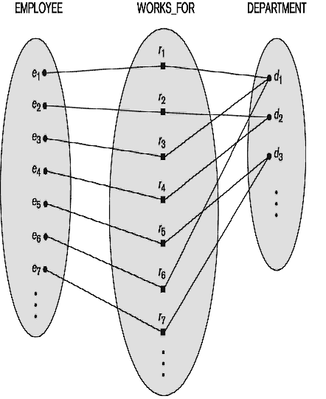

**Relationship Instances of the M:N WORKS_ON**

Relationship between EMPLOYEE and PROJECT

**EMPLOYEE WORKS_ON PROJECT**

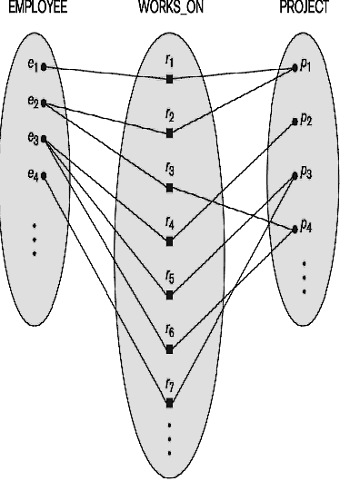

**Relationship Type vs. Relationship Set**

* Relationship Type:
  + Is the schema description of a relationship
  + Identifies the relationship name and the participating entity types
  + Also identifies certain relationship

constraints

* Relationship Set:
  + The current set of relationship instances represented in the database
  + The current *state* of a relationship type
* In ER diagrams, we represent the

*relationship type* as follows:

* + Diamond-shaped box is used to display a relationship type
  + Connected to the participating entity types via straight lines

# **Refining the COMPANY Database Schema by Introducing Relationships**

* By examining the requirements, six relationship types are identified
* All are *binary* relationships (degree 2)
* Listed below with their participating entity types:
  + WORKS_FOR (between EMPLOYEE,

DEPARTMENT)

* + MANAGES (also between EMPLOYEE, DEPARTMENT)
  + CONTROLS (between DEPARTMENT, PROJECT)
  + WORKS_ON (between EMPLOYEE, PROJECT)
  + SUPERVISION (between EMPLOYEE (as

subordinate), EMPLOYEE (as supervisor))

* + DEPENDENTS_OF (between EMPLOYEE, DEPENDENT)

**Discussion on Relationship Types**

* In the refined design, some attributes from the initial entity types are refined into relationships:
  + Manager of DEPARTMENT -> MANAGES
  + Works_on of EMPLOYEE -> WORKS_ON
  + Department of EMPLOYEE -> WORKS_FOR
  + etc
* In general, more than one relationship type can exist between the same participating entity types
  + MANAGES and WORKS_FOR are distinct relationship types between EMPLOYEE and DEPARTMENT
  + Different meanings and different relationship instances.
* Each entity type that participates in a relationship type plays a particular **role** in the relationship

# **Recursive Relationship Type**

* A relationship type where the same entity type participates more than once in the relationship in **distinct roles is called recursive relationship**
* Example: the SUPERVISION relationship
* EMPLOYEE participates twice in two distinct roles:
  + supervisor (or boss) role
  + supervisee (or subordinate) role
* Each relationship instance relates two distinct EMPLOYEE entities:
  + One employee in *supervisor* role
  + One employee in *supervisee* role

# **Displaying a Recursive Relationship**

# In a recursive relationship type.

# Both participations are same entity type in different roles.

# For example, SUPERVISION relationships between EMPLOYEE (in role of supervisor or boss) and (another) EMPLOYEE (in role of subordinate or worker).

* + In following figure, first role participation labeled with 1 and second role participation labeled with 2.
  + In ER diagram, need to display role names to distinguish participations.

**A Recursive Relationship Supervision**

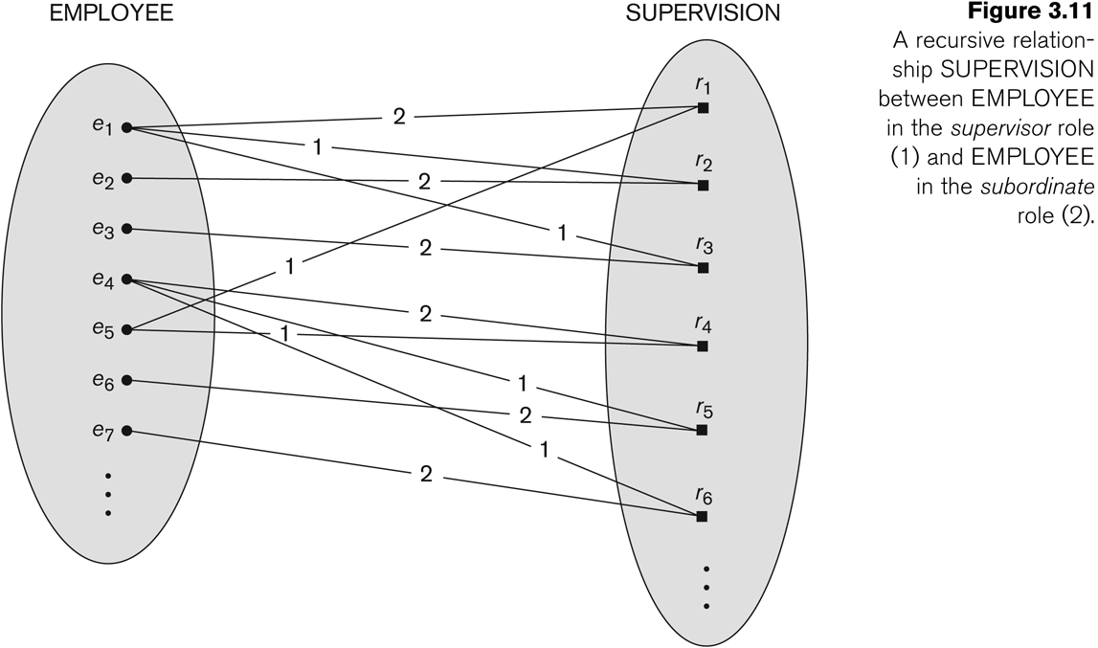

**Recursive Relationship type is : SUPERVISION (participation role names are shown)**

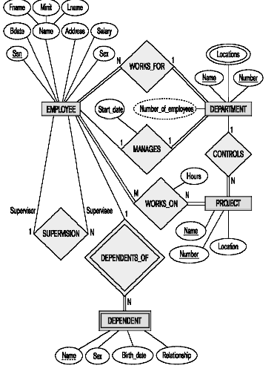

**Weak Entity Types**

* An entity that does not have a key attribute
* A weak entity must participate in an identifying relationship type with an owner or identifying entity type
* Entities are identified by the combination of:
  + A partial key of the weak entity type
  + The particular entity they are related to in the identifying entity type
* **Example:**
  + A DEPENDENT entity is identified by the dependent’s first name, *and* the specific EMPLOYEE with whom the dependent is related
  + Name of DEPENDENT is the *partial key*
  + DEPENDENT is a *weak entity type*
  + EMPLOYEE is its identifying entity type via the identifying relationship type DEPENDENT_OF
* A week entity type and its identifying relationship are distinguished by surrounding their boxes and diamonds with double lines
* The partial key attribute is underlined with a dashed or dotted line

**Constraints on Relationships**

* Constraints on Relationship Types
  + Cardinality Ratio (specifies ***maximum***

participation)

* + - One-to-one (1:1)
    - One-to-many (1:N) or Many-to-one (N:1)
    - Many-to-many (M:N)
  + Existence Dependency Constraint (specifies ***minimum*** participation) (also called participation constraint)
    - zero (optional participation, not existence- dependent)
    - one or more (mandatory participation, existence-dependent)

Many-to-One (N:1) Relationship

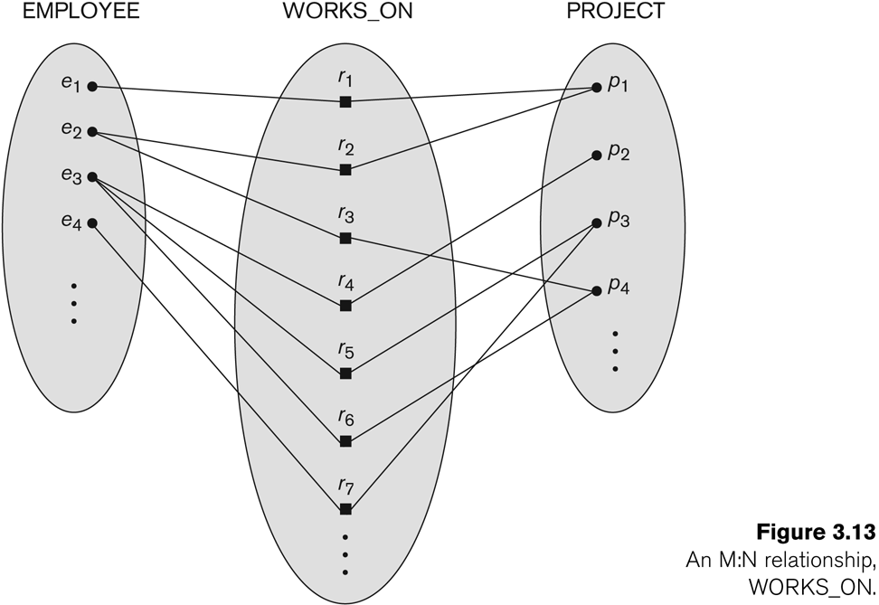

**Many-to-Many (M:N) Relationship**



**Attributes of Relationship Types**

* A relationship type can have attributes:
  + For example, HoursPerWeek of WORKS_ON
    - Its value for each relationship instance describes the number of hours per week that an EMPLOYEE works on a PROJECT.
    - A value of HoursPerWeek depends on a

particular (employee, project) combination

* + Most relationship attributes are used with M:N relationships
    - For M:N relationships, some attributes are determined by the combination of participating entities, not by a single entity. Such attributes must be specified as relationship attributes
    - In 1:1 relationships, they can be transferred

to one of the participating entities

* + - In 1:N relationships, they can be transferred to the entity type on the N-side of the relationship
    - The decision as to where a relationship attribute should be placed is determined subjectively by the schema designers

## **Example Attribute of a Relationship Type: Hours of WORKS_ON**

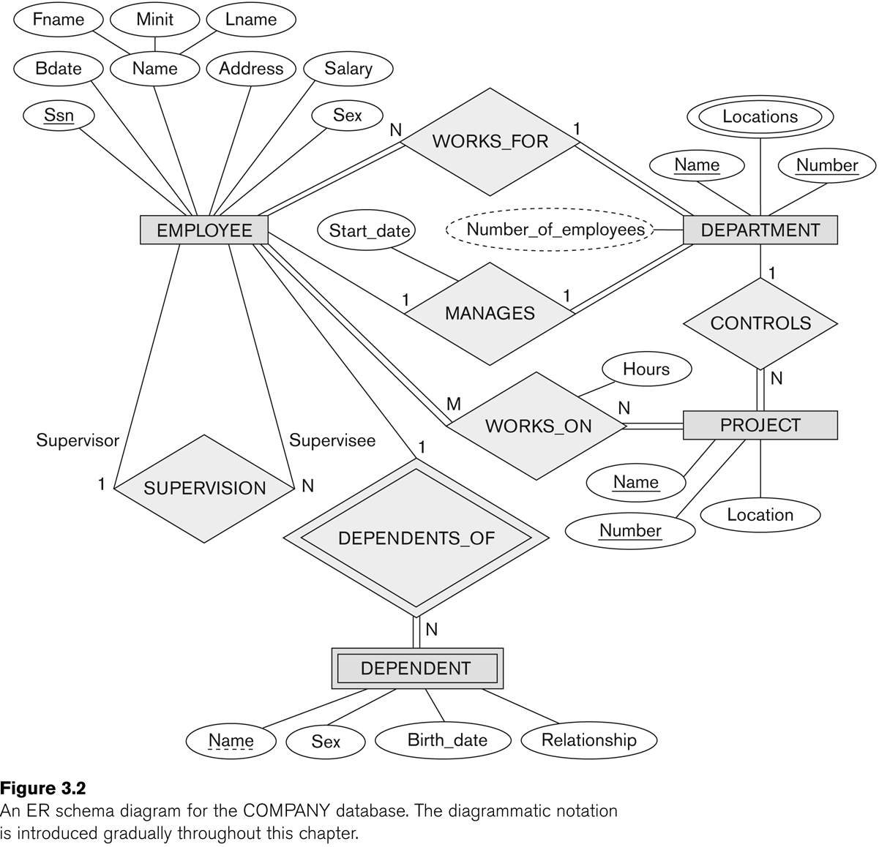

**Notation for Constraints on Relationships**

* Cardinality ratio (of a binary relationship): 1:1, 1:N, N:1, or M:N
  + Shown by placing appropriate numbers on the relationship edges.
* Participation constraint (on each participating entity type): **total** (called existence dependency) or **partial**.
  + Total shown by double line, partial by single line.
* NOTE: These are easy to specify for Binary Relationship Types.
* Structural Constraints = Cardinality Ratio Constraints + Participation Constraints

## **Alternative (min, max) Notation for Relationship Structural Constraints**

* Specified on each participation of an entity type E in a relationship type R
* Specifies that each entity e in E participates in at least *min*

and at most *max* relationship instances in R

* Default (no constraint): min=0, max=n (signifying no limit)
* Must have min<=max, min>=0, max >=1
  + min=0 implies partial participation; min>0 implies total participation
* Derived from the knowledge of mini-world constraints
* Examples:
  + A department has exactly one manager and an employee can manage at most one department.
    - Specify (1,1) for participation of DEPARTMENT in MANAGES
    - Specify (0,1) for participation of EMPLOYEE in MANAGES
  + An employee can work for exactly one department but a department can have any number of employees.
    - Specify (1,1) for participation of EMPLOYEE in WORKS_FOR
    - Specify (1,n) for participation of DEPARTMENT in WORKS_FOR

## **The (min,max) Notation for Relationship Constraints**

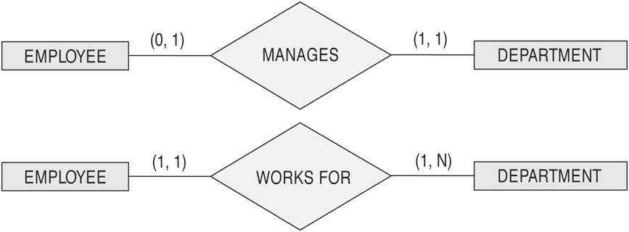

* Read the min,max numbers next to the entity type and looking away from the entity type

**Summary of Notation for ER Diagrams**

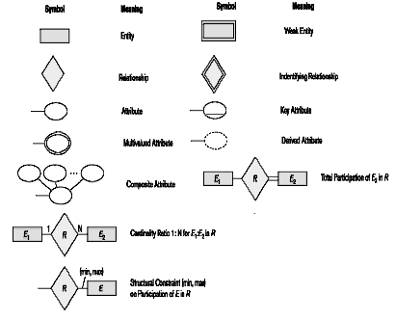

**COMPANY ER Schema Diagram Using (min, max) Notation**

